Final Report for Mid Term Project
RSH E Shopping Junction



Submitted To:
Nazeef Ul Haq
Submitted By:
Muhammad Rauf 2022-CS-37
Abdul Saboor 2022-CS-10
Harmain Iftikhar 2022-CS-07

Project ID: DSAMidProjectPID13

University of Engineering and Technology
Lahore, Pakistan
Table of Contents:

- Learning Outcomes
- Executive Summary
- Scrapping
3.1 Problem Statement
3.2 Project Overview
3.3 Attributes
3.4 Algorithms
3.4.1 for Sorting
3.4.2 for Searching
3.5 Obstacles
3.6 Resources for Development
4- Description for Algorithms
4.1 Algorithm Explanation
4.2 Pseudo Code
4.3 Time Complexity
4.4 Strength
4.5 Weakness
4.6 Dry run
- GUI of the Software
5.1 Products Page UI

Learning Outcomes:
- In this project we learnt scrapping data from websites, using requests.
- We learnt to store data in csv files using pandas.
- We learnt how to design UI (User Interface) and connect it with the backend to work properly.
- We learnt implementing multiple functions on data like, sorting, Multiple level Sorting, searching.

Executive Summary:
The software includes data that can be organized through various sorting algorithms and searched using different search algorithms. This enables users to view the entire product catalog and arrange the products in accordance with their specific requirements. There are a total of eight sorting algorithms provided, allowing users to choose any of them for sorting purposes.
Within the software, there are nine product attributes that users can choose for sorting. Users are required to select both the sorting algorithm and the specific attribute they wish to use for sorting. Additionally, the software offers a search function that allows users to find products by simply entering relevant keywords or terms.
Scrapping:
- Scrapping Link:
"https://www.ebay.com/sch/i.html?_from=R40&_trksid=p2334524.m570.l1313&_nkw=printer&_sacat=0&LH_TitleDesc=0&_fsrp=1&Brand=Zebra%7CLexmark&rt=nc&_odkw=printer&_osacat=0&_dcat=1245&_oaa=1"
- Problem Statement:
In contemporary times, individuals embarking on a new business venture must possess a comprehensive understanding of the products they intend to sell. They require access to a platform that can provide them with all the necessary information about these products.
- Project Overview:
This software has been designed to address the issue mentioned in point 1. It assists users in acquiring product information, including user ratings, enabling them to identify highly-rated products to stock. This, in turn, can enhance their earnings. Furthermore, the software allows users to assess the prices of scraped products, helping them select items within their budget for their shop.

The website continuously updates with newly launched products in the market, offering users the opportunity to be among the first to stock and sell these items, potentially leading to substantial profits. Additionally, the software provides users with the ability to check shipping rates for products they wish to source from the website, allowing them to choose the most suitable seller..
Attributes:
- Type Of Product
- Name Of Product
- Brand Name
- Out Of Stock
- Price Of Products
- Discount On Product
- Delivery Charges
- Sold Products
- Ratings
Algorithms:
- For Sorting:
- Merge Sort
- Insertion Sort
- Selection Sort
- Bubble Sort
- Quick Sort
- Counting Sort
- Radix Sort
- Bucket Sort
- For Searching:
- Linear Search
- Obstacles:
Certain websites have restrictions that prevent data scraping. The website we're currently utilizing permits data scraping for up to five pages. However, when we accessed a link where the page structure was altered, and new products were incorporated into existing pages, the software encountered issues. Specifically, when dealing with substantial data, such as when working with thousands of products, the software experiences slowdowns, and the sorting process becomes time-consuming.
- Resources for development:
- Spyder as IDE
- Python as Programming Language
- PYQT5 for the Designing of UI

Description for Algorithms:
Merge Sort:
Merge sort is a comparison-based algorithm. It works on the divide and conquer principle. It divides the array into small parts until there are only two elements left. Then it swaps the elements and sorts them. When all the elements are sorted it again merges them to an array.
Pseudocode:
Merge-Sort(array, p , r, col-index)
if p != r then
Let q = ((p+r)/2) (Round and return the largest closest number)
Merge-Sort(array, p, q, col-index)
Merge-Sort(array, q+1, r ,col-index)
Merge(array, p, q, r ,col-index)
return array
Merge(array, p, q, r , col-index )
Let n1 = q-p (Convert in integer)
Let n2 = r-q (Convert in integer)
Let Left-array = []
Let Right-array = []
for i = 0 to n1
append array[i+p] in Left-array
for i = 0 to n2
append array[i+q] in Right-array
Let i = 0
Let j = 0
Let k = p
Call Selection-Sort (left-array, col-index)
Call Selection-Sort (right-array, col-index)
while i < left-array.length and j<right-array.length
if left-array[i][col-index] < right-array[j][col-index]
append the elements from the left array to array[k]
else
append the elements from the left array to array[k]
k +=1
while i < left-array.length
append remaining elements of left-array to array[k]
while j < len(right_arry)
append remaining elements of right-array to array[k]
Python Code:
def MergeSort(self,arry,p ,r, col_index):
if p != r :
q = math.floor((p+r)/2)
self.MergeSort(arry,p,q,col_index)
self.MergeSort(arry, q+1, r,col_index)
self.Merge(arry,p,q,r,col_index)
return arry
def Merge(self,arry,p,q,r ,col_index ):
n1 = int(q-p)
n2 = int(r-q)
left_arry = []
right_arry = []
for i in range(0,n1):
left_arry.append(arry[i+p])
for i in range(0,n2):
right_arry.append(arry[i+q])
i = 0
j = 0
k = p
self.selection(left_arry,col_index)
self.selection(right_arry,col_index)
while i<len(left_arry) and j<len(right_arry) :
if left_arry[i][col_index]<right_arry[j][col_index]:
arry[k] = left_arry[i]
i +=1
else:
arry[k] = right_arry[j]
j +=1
k +=1
while i < len(left_arry):
arry[k] = left_arry[i]
i += 1
k += 1
while j < len(right_arry):
arry[k] = right_arry[j]
j += 1
k += 1
Time Complexity:
Worst Complexity: O(n*log(n))
Average Complexity: O(n*log(n))
Best Complexity: O(n*log(n))
Strength:
It is faster while working with the large amount of data.
Weakness:
It is slower while working for the small amount of data.
Dry Run:
Split Merge
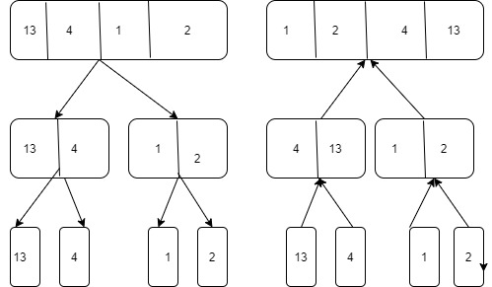
Insertion Sort:
Insertion sort is a comparison-based algorithm in this algorithm array is divided into two parts sorted elements are put on one side and the unsorted on the other side. The algorithm keeps finding the elements from the unsort part and put it in the sorted part of the array.
Pseudocode:
insertionSort(A)
for i = 1 to A.length
key=A[i]
for j=i-1 to A.length
if j>=0 and key < A[j]
swap(A[j], A[i])
Python Code:
def Insertion_Sort(self,col_index) :
for i in range(1,len(self.arry)):
Arry_Inside_As_key = self.arry[i]
j = i -1
for j in range(len(self.arry)):
Arry_Inside = self.arry[j]
if (Arry_Inside_As_key[col_index])< (self.arry[j][col_index]):
temp = self.arry[j]
self.arry[j] = self.arry[i]
self.arry[i] = temp
Time Complexity:
Worst Complexity: O(n²)
Average Complexity: O(n²)
Best Complexity: O(n)
Strength:
It works faster for the small amount of data.
Weakness:
It works slower if the amount of data is large.
Dry Run:
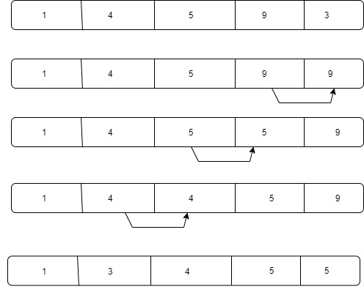
Selection Sort:
Selection sort is a comparison-based algorithm it finds the smallest number and then takes it to the first index of the array then finds the second smallest number and put it to the second index and similarly for others. In the last array is sorted.
Pseudocode:
Selection-Sort(array, col-index):
for I = 1 to array.length
let min-index = I
for j= i+1 to array.length
let array-Inside = array[j]
let array-Inside-At-Min-index = array[min-index]
if col-index != 0 then
if array-Inside[col-index]) < (array-Inside-At-Min-index[col-index] then
min-index = j
array-Inside-At-Min-index = array[j]
Swap (array[min-index], array[i])

Python Code:
def selection(self,arry,col_index):
#complete selection sort
for I in range(1,len(arry)):
min_index = I
for j in range(i+1,len(arry)):
Arry_Inside = arry[j]
Arry_Inside_At_Min_index = arry[min_index]
if col_index != 0:
if (Arry_Inside[col_index]) < (Arry_Inside_At_Min_index[col_index)
min_index = j
Arry_Inside_At_Min_index = arry[j]
temp = arry[min_index]
arry[min_index] = arry[i]
arry[i] = temp
Time Complexity:
Worst Complexity: O(n²)
Average Complexity: O(n²)
Best Complexity: O(n²)
Strength:
No additional temporary memory storage is need for the selection sort. It sorts the elements in the same array.
Weakness:
With the increase in the amount of the data it becomes slower.
Dry Run:
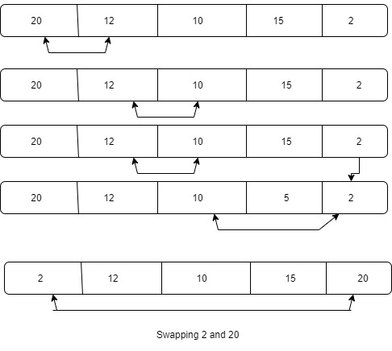

Bubble Sort:
Bubble sort is a comparison-based algorithm It compares two adjacent elements and swap them then same for the next two elements. It does this process until all the elements are sorted in the array.
Pseudocode:
Bubble-Sort(col-index)
for i=0 to array.length
for j = 1 to array.length
let array-Inside = array[j]
let array-Inside-Next = array[j+1]
If col-index != 0 then
if (array-Inside[col-index]) > (array-Inside-Next[col-index]):
swap(array[j], array[j+1])
Python Code:
def bubble(self,col_index) :
#complete bubble Sort
for I in range(len(self.arry )):
for j in range(1,len(self.arry )-1):
Arry_Inside = self.arry[j]
Arry_Inside_Next = self.arry[j+1]
if col_index != 0 :
if (Arry_Inside[col_index])>(Arry_Inside_Next[col_index]):
temp = self.arry[j]
self.arry[j] = self.arry[j+1]
self.arry[j+1] = temp
Time Complexity:
Worst Complexity: O(n²)
Average Complexity: O(n²)
Best Complexity: O(n)
Strength:
Its code is very small and easy to understand. It is faster for the small amount of data and for the data that is mostly in order.
Weakness:
It takes a lot of time for sorting large amount of data. It can take O(n²) time.
Dry Run:
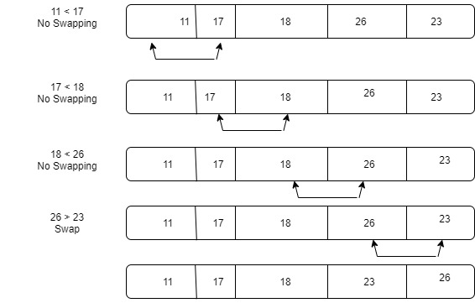
Quick Sort:
It is a comparison-based sorting algorithm. It has a pivot point. In this algorithm the array is broken into small parts then it makes comparison of the elements around the pivot and arranges the elements. In the last the array is again combined. The resulted array is sorted now.
Pseudocode:
Quick-Sort(array, Start, End , col-index):
if Start<End then
Let Pivot = partition(array, Start, End, col-index)
Call Quick-Sort(array, Start, Pivot-1, col-index)
Call Quick-Sort(array, Pivot+1, End, col-index)

partition(array, Start, End, col-index):
Let Pivot = array[End][col-index]
p = Start – 1
for I = Start to End
if col-index != 0 then
if Pivot >= (array[i][col-index]) then
p+=1
swap(array[p], array[i])
swap(array[p+1], array[End]
return(p+1)
Python Code:
def Quick_Sort(self,Arry,Start,End , col_index):
if Start<End:
location_Pivoit = self.partision(Arry,Start,End,col_index)
self.Quick_Sort(Arry,Start,location_Pivoit-1,col_index)
self.Quick_Sort(Arry,location_Pivoit+1 ,End,col_index)
def partision(self,Arry,Start,End,col_index):
Pivoit = Arry[End][col_index]
p = Start – 1
for I in range(Start,End):
if col_index != 0:
if (Pivoit)>= (Arry[i][col_index]):
p+=1
temp = Arry[i]
Arry[i] = Arry[p]
Arry[p] = temp
temp = Arry[End]
Arry[End] = Arry[p+1]
Arry[p+1] = temp
return(p+1)
Time Complexity:
Worst Complexity: O(n²)
Average Complexity: O(n*log(n))
Best Complexity: O(n*log(n))
Strength:
Quick Sort is very fast in sorting the elements. As it has to decide from the pivot point to sort the elements.
Weakness:
Quick sort is recursive there for it can take O(n²) time to sort the elements in the worst case.
Dry Run:
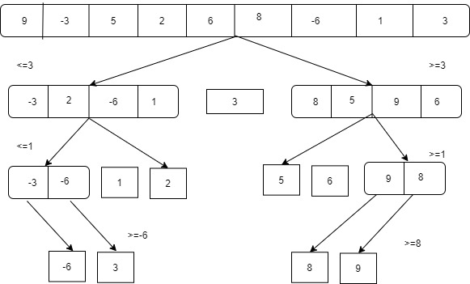
Bucket Sort:
It divides items into multiple groups called buckets. Bucket sort items are first divided evenly into groups called buckets and then sorted using other sorting algorithms. Then sort and collect the elements.
Strength:
It works faster on float value.
Weakness:
Can not work faster on any other data type except float.
Time Complexity:
Best Case: Ω(n +k) Average: θ(n +k) Worst case: O(n²)
Pseudocode:
procedure bucketSort(arr: List of comparable items)
n = length(arr)
buckets = array of empty lists
for I from 0 to n-1
bucketIndex = (arr[i] * n) // MaxValue
append arr[i] to buckets[bucketIndex]
for I from 0 to n-1
sort(buckets[i])
result = concatenate all lists in buckets
return result
Python Code:
def insertion_sort(arr):
for I in range(1,len(arr),+1):
x = arr[i]
j = i-1
while arr[j] > x and j > -1:
arr[j+1] = arr[j]
j -= 1
arr[j+1] = x
return arr
def bucket_sort(arr):
list_in_list = []
num = 10
for a in range(num):
list_in_list.append([])

for a in arr:
integer_no = int(a * num)
list_in_list[integer_no].append(a)

for a in range(num):
list_in_list[a] = insertion_sort(list_in_list[a])
k = 0
for I in range(num):
for j in range(len(list_in_list[i])):
print(i)
arr[k] = list_in_list[i][j]
k += 1
return arr
x = [0.565, 0.656,0.897, 0.1234, 0.665, 0.3434]
print(“Sorted Array is”)
print(bucket_sort(x))
Radix Sort:
It is a linear sorting algorithm in which we sort elements of arrays by comparing their digits. First, very right digit of every elements of array is compared with each other and sort elements with respect to very right digit. This process repeats for further digits and hence array becomes sorted.
Pseudocode:
function radixSort(arr)
max_num = maximum value in arr
max_digits = number of digits in max_num
for I from 0 to 9:
buckets[i] = empty list
for digit_position from 1 to max_digits:
for I from 0 to length(arr) – 1:
digit = (arr[i] / 10^(digit_position – 1)) % 10
buckets[digit].append(arr[i])
arr = concatenation of all buckets
for I from 0 to 9:
buckets[i] = empty list
return arr
Python Code:
def radixSort(arr):
max_num = max(arr)
max_digits = len(str(max_num))
for digit_position in range(1, max_digits + 1):
buckets = [[] for _ in range(10)]
for num in arr:
digit = (num // 10**(digit_position – 1)) % 10
buckets[digit].append(num)
arr = [num for bucket in buckets for num in bucket]
return arr
arr = [170, 45, 75, 90, 802, 24, 2, 66]
sorted_arr = radixSort(arr)
print(sorted_arr)

Dry Run:
Unsorted Array:

89 | 231 | 12 | 100 | 90

100 | 90 | 231 | 12 | 89
100 | 12 | 231 | 89 | 90
Sorted Array:
12 | 89 | 90 | 100 | 231

Time Complexity:
O(d*(n+b))
Strength:
Radix Sort has linear time complexity when the number of digits in the input numbers is relatively small compared to the number of elements.
Weakness:
Radix Sort is not a comparison-based sorting algorithm, which means it is not suitable for sorting elements with arbitrary order relationships.
Counting Sort:
Counting Sort is a linear algorithm that sorts the elements of and array by counting the number of occurrences of each unique element in the array. If searches for the occurrences of a number and then put it in the array at that index of number. For example, the number searched is 5 then it will put all the occurrence of the number at index five of the array.
Pseudocode:
Counting-Sort(array, col-index)
Let Col-Price = [val[col-index] for val in array]
Let Max-Element = Get maximum of (Col-Price)
Let Min-Element = Get minimum of (Col-Price)
Let range = Max-Element – Min-Element + 1
Let Count = array of zero of size of (range)
Let Output = array of zero of size of (array)
for I = 0 to array.length
Count[array[i][col-index]-Min-Element] +=1
for i= 1 to Count.length
Count[i] += Count[i-1]
for i= array.length down to 0
j = Count[array[i][col-index]-Min-Element] – 1
Output[j] = array[i]
Count[array[i][col-index]-Min-Element] - =1
return output

Python Code:
def counting(self,Arry, col_index) :
col_Price = [val[self.col_index] for val in Arry]
Max_Element = max(col_Price)
Min_Elemenet = min(col_Price)
rang = Max_Element – Min_Elemenet + 1
Count = [0]*(rang)
Output = [0]*len(Arry)
for I in range(0,len(Arry)):
Count[Arry[i][col_index]-Min_Elemenet] +=1
for I in range(1,len(Count)):
Count[i] += Count[i-1]
for I in range(len(Arry)-1,-1,-1):
j = Count[Arry[i][col_index]-Min_Elemenet] – 1
Output[j] = Arry[i]
Count[Arry[i][col_index]-Min_Elemenet] -=1
return (Output)
Time Complexity:
Worst Complexity: O(n)
Average Complexity: O(n+k)
Best Complexity: O(n+k)
Strength:
Counting sort is the faster then all the comparison bases sorting algorithms.
Weakness:
Counting sort is only works for the integers. It sorts the string because it cannot make buckets of characters to strings there. It need integers to keep the count of the elements.
Dry Run:
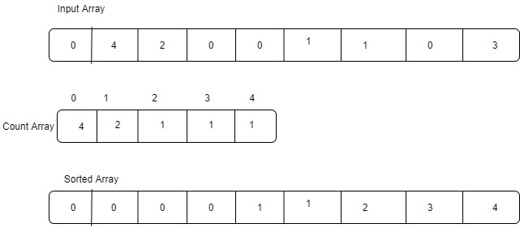
Searching Algorithms:
Linear Search:
In this searching algorithm. The element is searching is started from the first index of the array. If the element is found before the last elements it returns the elements. If not, it will run until the last index of the array.
Pseudocode:
Linear-Search(array, element)
Let array1=[]
for i= 0 to array.length
if element==array[i]
append the element to array1
def linearSearch(array, element)
array = [ ]
for I in range (len(array)):
if element in array[i]:
print(array[i])
array.append(array[i])
Time Complexity:
Worst Complexity: O(n)
Average Complexity: O(n)
Best Complexity: O(1)
Strength:
The biggest advantage of the linear sort is that it can find the element even from the unsorted array. It works very good for small amount of data. It can find strings from the data also.
Weakness:
For large amount of data linear sort may take a lot of time to search an element.
Dry Run:
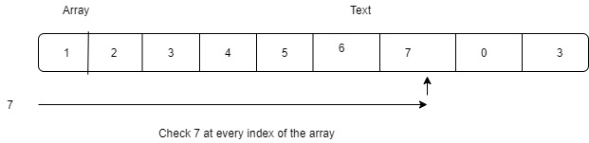

GUI of the Software:
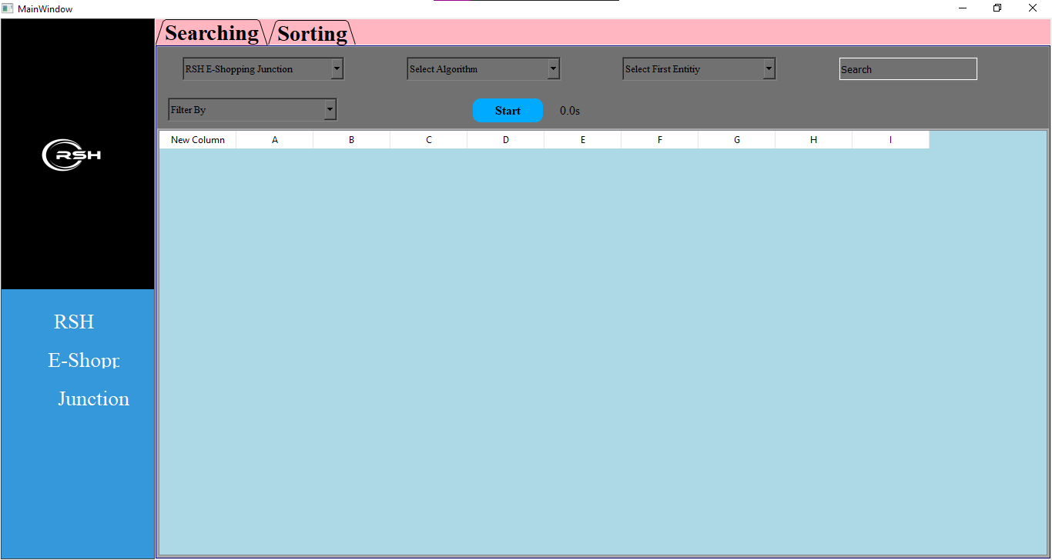
Fig 1: Basic Interface
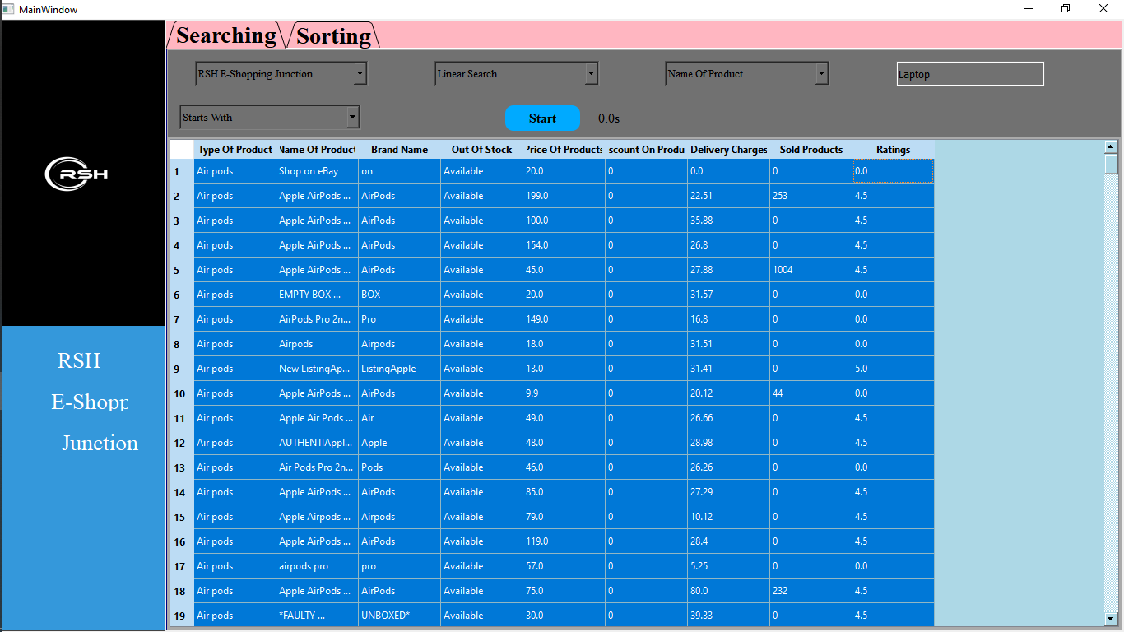
Fig 2: Sorting Interface
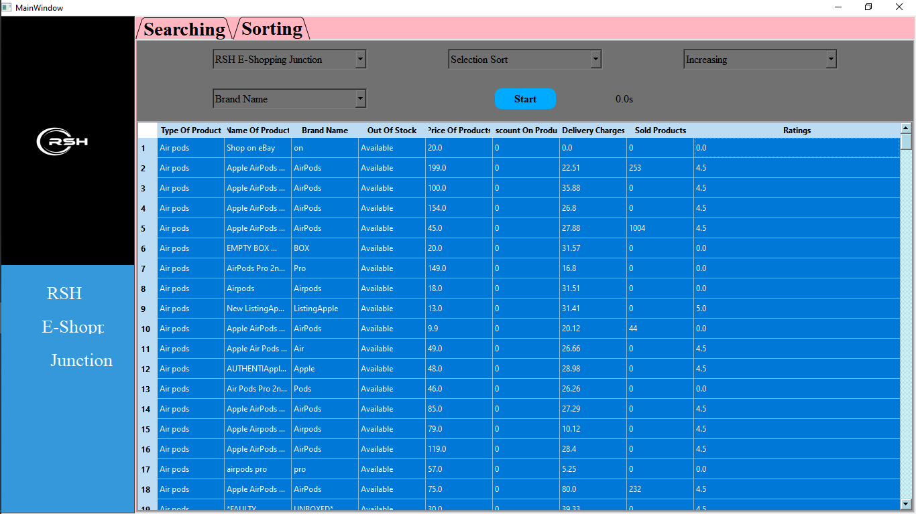
Fig 3: Complete GUI

